NAME: _____________ | Computer Programming
Lego Classes | DATE: Monday, December 05, 2016
/*
* This class represents a lego piece.
* It has an x,y (its location on grid - the upper left stud is 0,0
* It has a color - if not chosen it is anything
* The width is the horizontal distance, length - vertical
* Direction is either horizontal or vertical. By default it is horizontal. *
*/
public class LegoPiece
{
int x;
int y;
int width;
int length;
Color color;
String direction="horizontal";
int level=1;

public LegoPiece (int theWidth, int theLength)
{
width=theWidth;
length=theLength;
}

public LegoPiece (int theWidth, int theLength, Color theColor)
{
width=theWidth;
length=theLength;
color=theColor;
}

public void setDirection(String newDirection)
{
direction=newDirection;
}
public void setLocation(int newX, int newY)
{
x=newX;
y=newY;
}
//This method will put this lego piece on top other lego piece with same upper left coordinate.
//note lego's coordinates start at 0,0.
public void snapTo(LegoPiece otherPiece, int legoX, int legoY)
{
x=otherPiece.x+legoX;
y=otherPiece.y+legoY;
level=otherPiece.level++;
}
}
The class to the right represents a lego piece.
Try to follow the instructions to create my shape:
public void myInstructions()
{
LegoPiece rect1=new LegoPiece(4,2);
rect1.setDirection("vertical");
rect1.setLocation(2,0);
LegoPiece square1=new LegoPiece(2,2);
square1.setLocation(0,1);
LegoPiece square2=new LegoPiece(2,2);
square2.setLocation(4,1);
LegoPiece rect2=new LegoPiece(2,1);
rect2.snapTo(square1,1,0);
LegoPiece rect3=new LegoPiece(2,1);
rect3.snapTo(rect1,1,1);
LegoPiece rect4=new LegoPiece(2,1);
rect4.snapTo(rect2,1,0);
LegoPiece square3=new LegoPiece(2,2,Color.red);
square3.snapTo(rect4,0,0);
}

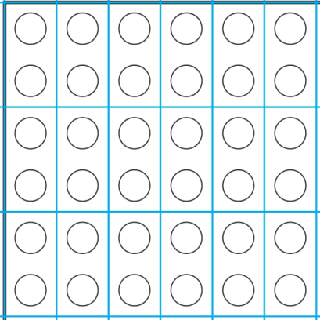
Create your own instruction sheet. You can use up to 10 bricks.

